Exercise #14
- Our Ceo fall in love with the petite Web Developer, Anamika Pandit. She now wants her last name to be changed to ‘Sharma’.
-- …Bro
UPDATE employee_table SET l_name = 'Sharma' WHERE f_name = 'Anamika' AND l_name = 'Pandit' AND title = 'Web Developer';
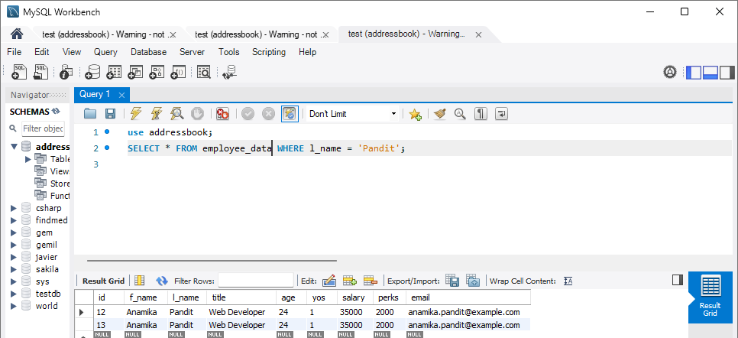
- All Multimedia Programmers now want to be called Multimedia Specialists.
UPDATE employee_data title “Mutimedia Specialist” where title=”Multimedia Programmer”;
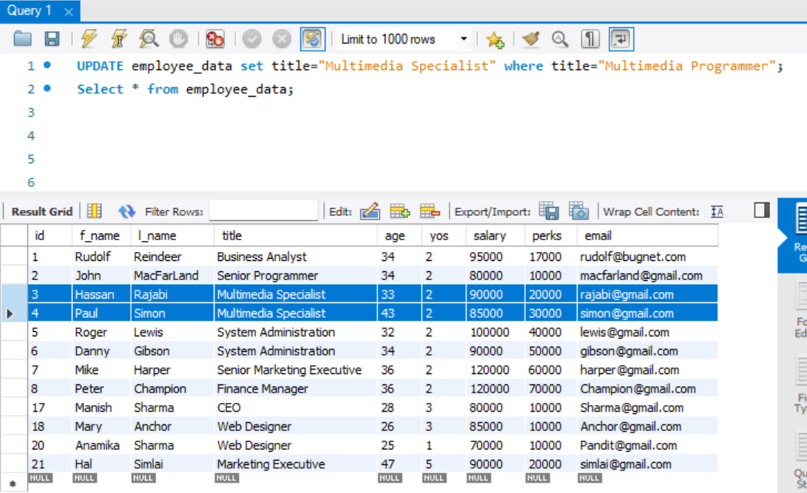

- After his marriage, the CEO gives everyone a raise. Increase the salaries of all employees (except the CEO) by $10
UPDATE employee_data set salary=salary + 10000 where title NOT LIKE “CEO”;
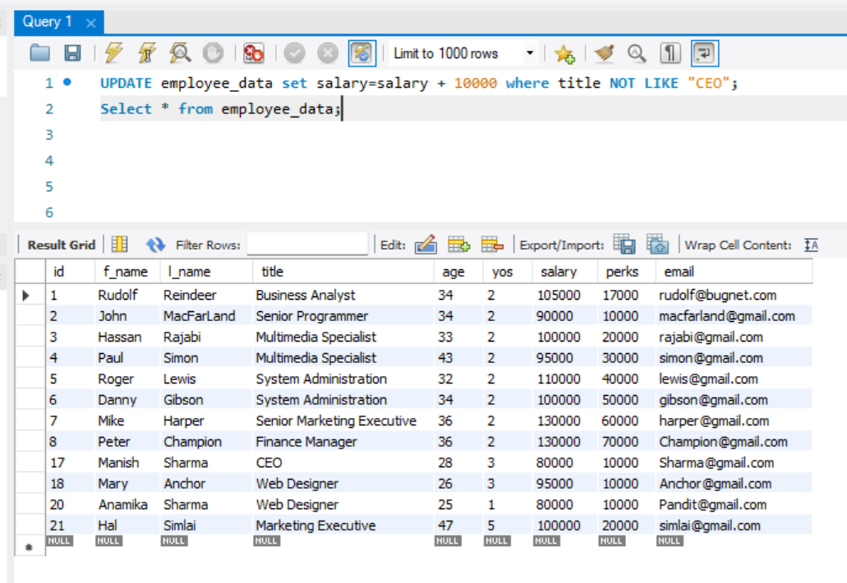000.

